**Azure Virtual network and Virtual Machines**

Case Study:

1. Create an ARM template for a virtual network with subnets and network security group with inbound outbound rules.

Below are the screenshots of the template.

Screenshot 1:

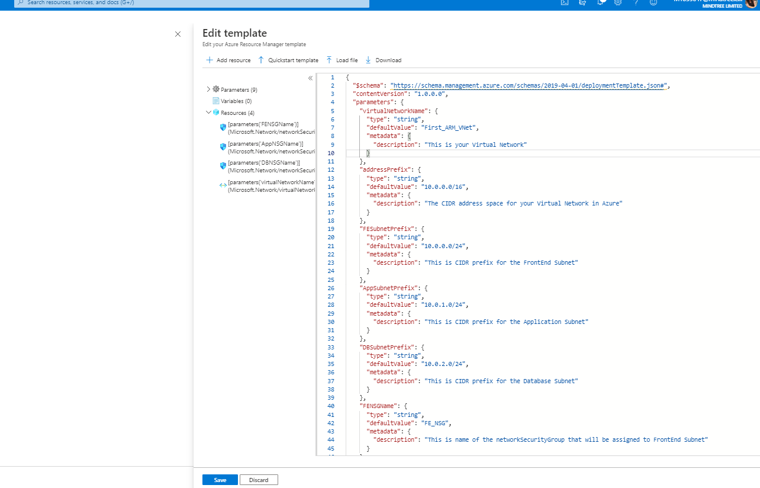

Screenshot 2:

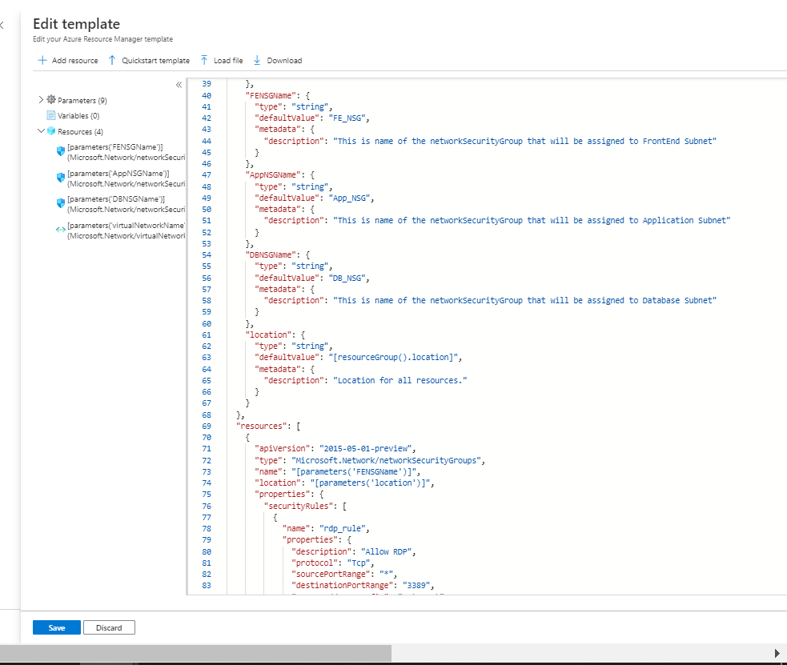

Screenshot 3:

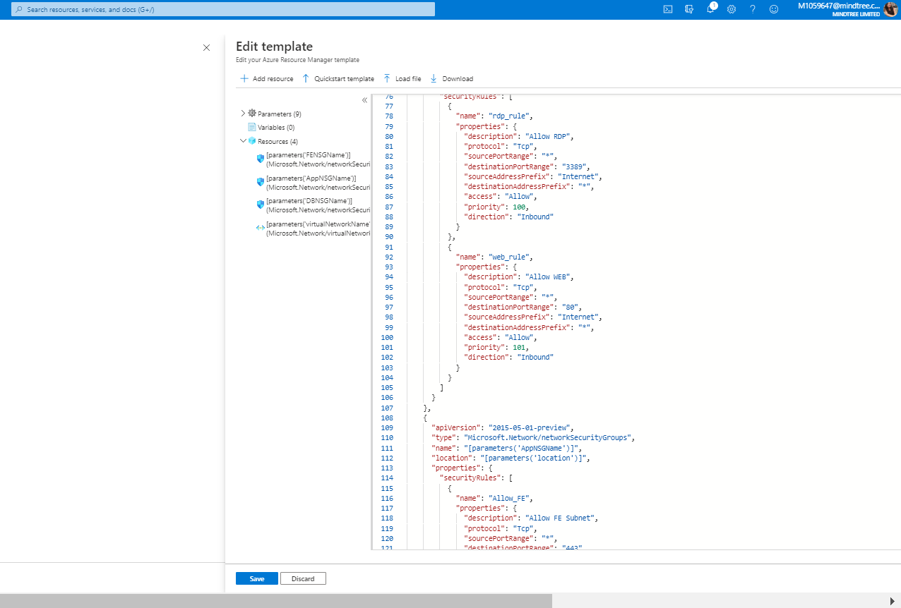

Screenshot 4:

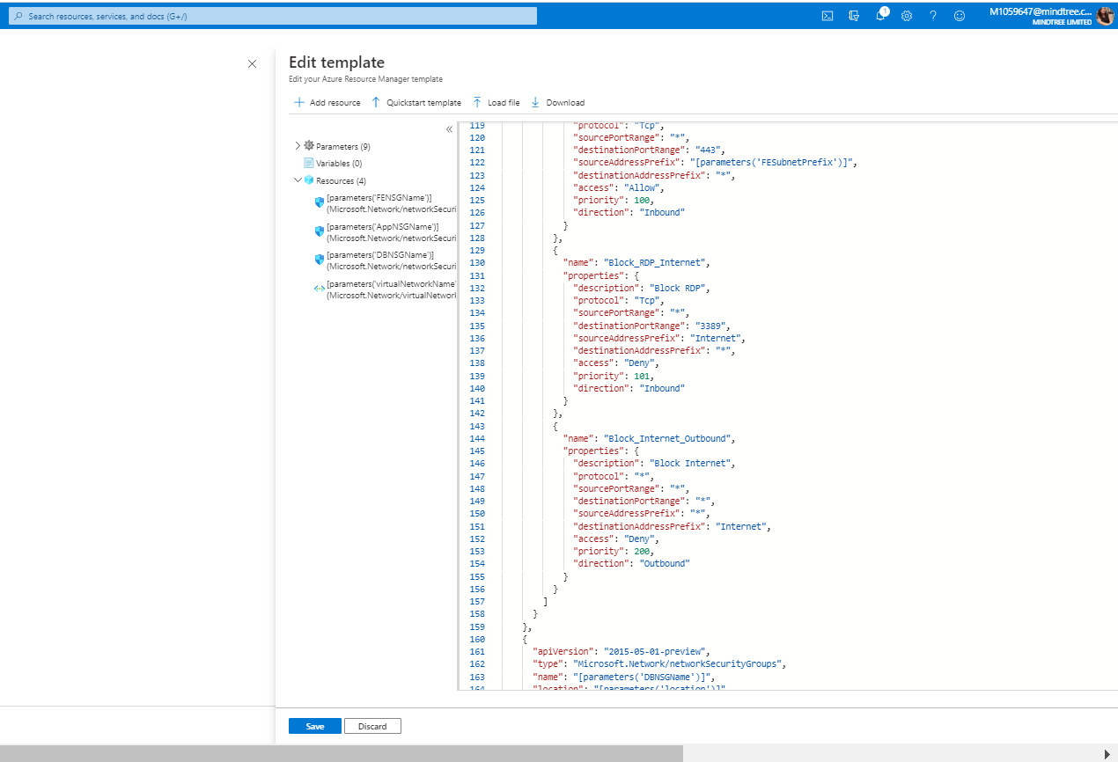

Screenshot 5:

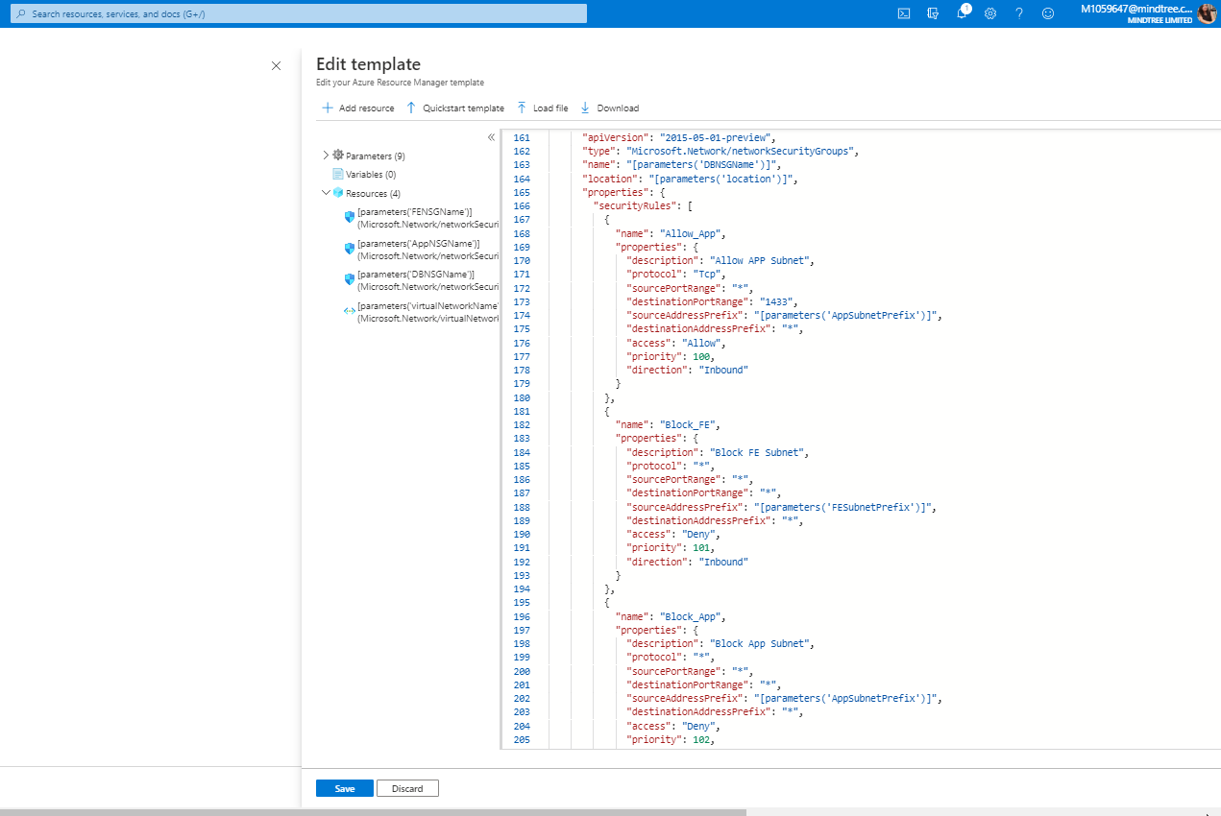

Screenshot 6:

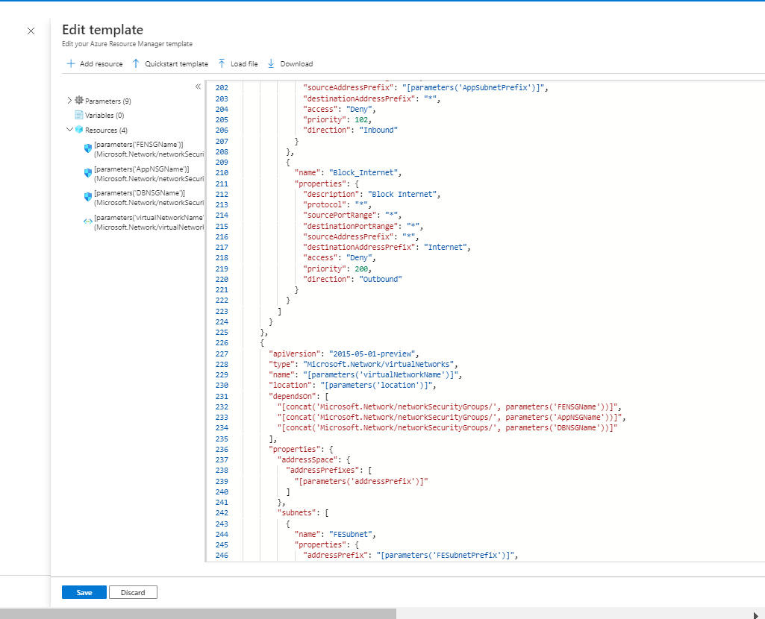

Screenshot 7:

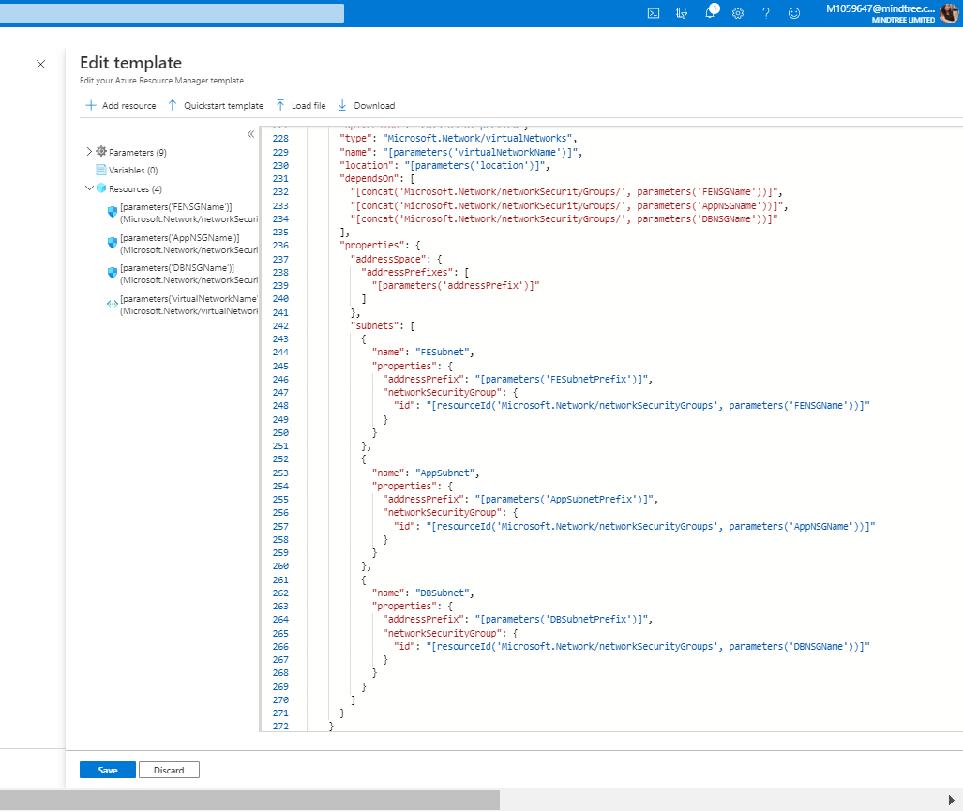

Screenshot 8:

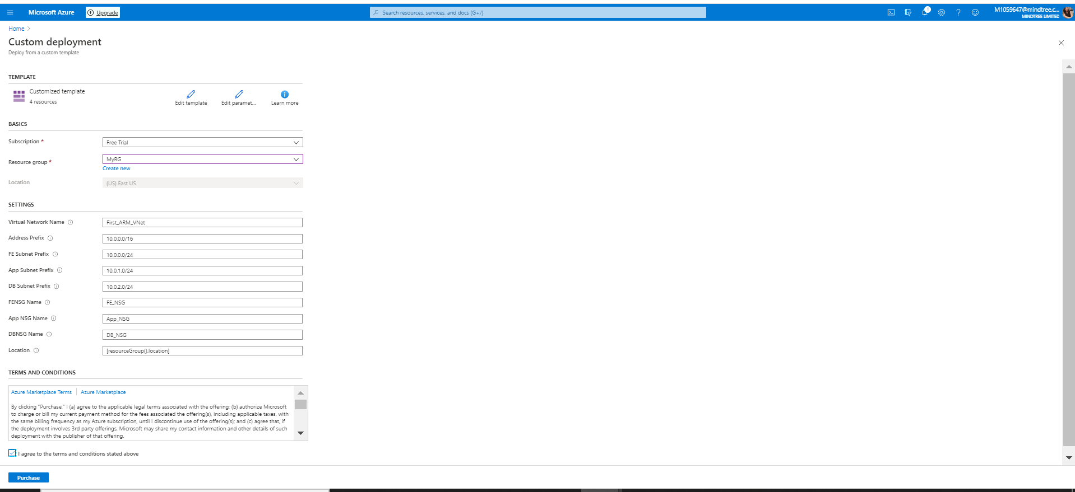

Screenshot 9:

